**DEVICE NAME:** Bought TM4C123GXL, SOFTWARE: **TM4C123GH6PM**

**The TIVA C series board EK-TM4C123GXL is commonly associated with the TM4C123GH6PM microcontroller. This specific microcontroller should be listed under the options in the IAR Embedded Workbench IDE. The name may be partially obscured or might require careful scrolling through the list, but you should look for "TM4C123GH6PM" as this matches the microcontroller used in the EK-TM4C123GXL board.**

**Lesson#0: Modern Embedded Systems Programming: Getting Started**

* Download and install stellaris id for USB driver
* Download and install IAR tool set
* Download and install Keil Microvision
* Download and install the stellaris id debugger for Keil Microvision
  + Keil MDK do not support the Stellaris ICE
* Download Course Lectures
* **FIKAR: ARM ARCHITECTURE AND GITHUB COMMANDS**

**Lesson#01: How computers count?**

* Create an IAR Project C->main.c->OK
* Select a device: LM4F120H5QR

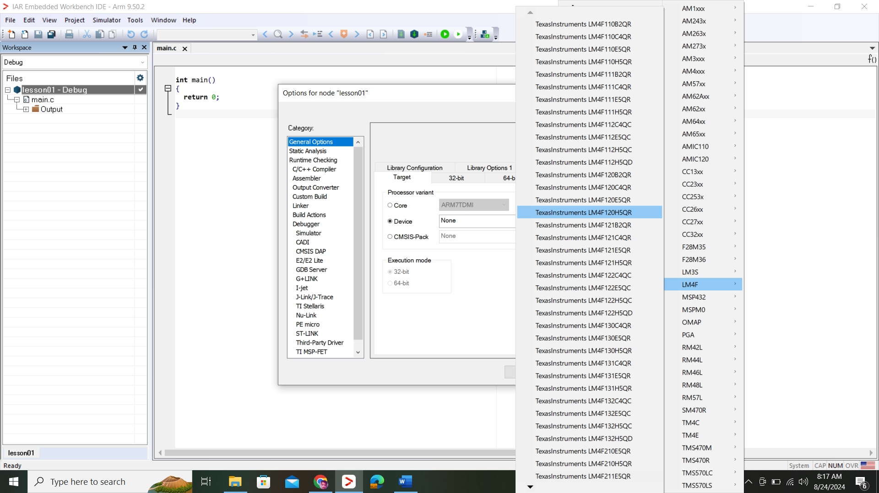

* Makesure optimization set to low:

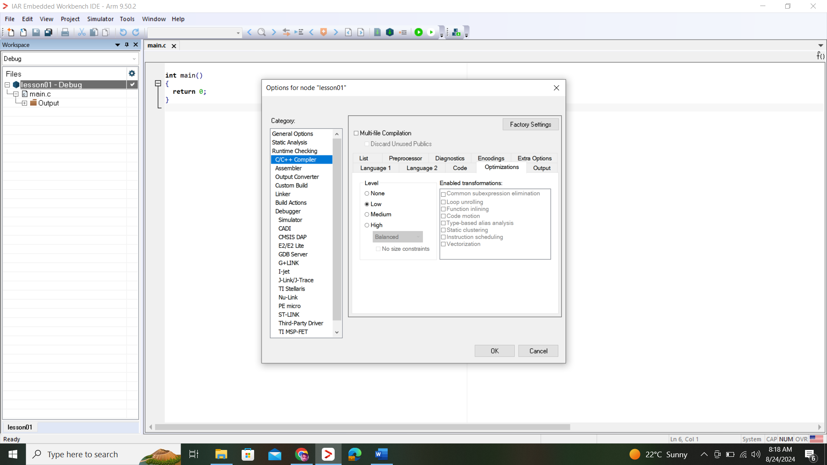

* Make some IDE customization more:

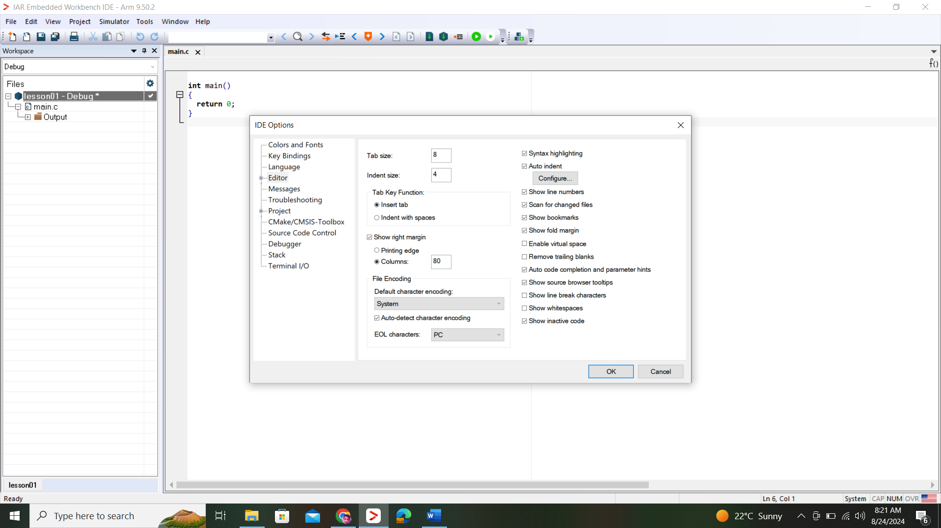

* To compile a code Set workspace: shortcut key fn+F7   
  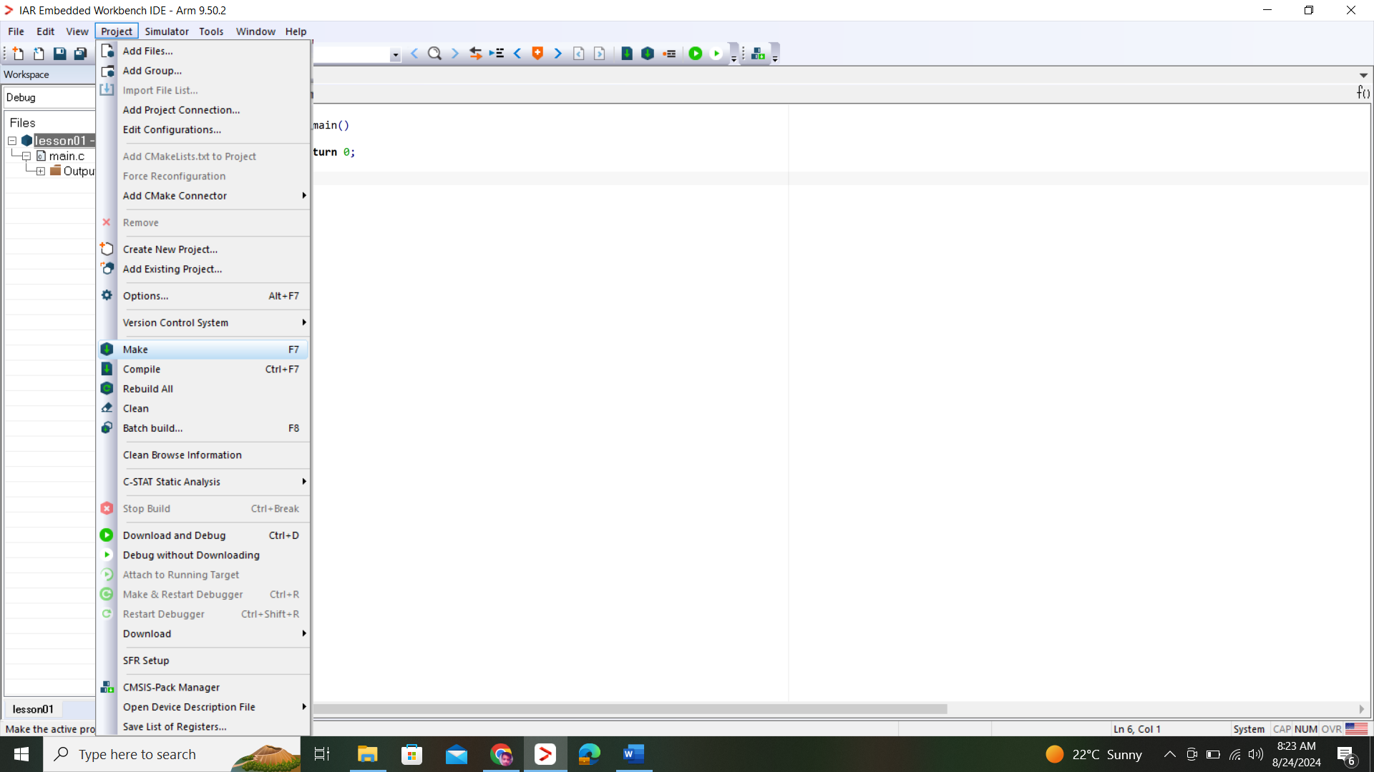
* Code and run now configure simulator
* Cross check whether simulator is running or not:

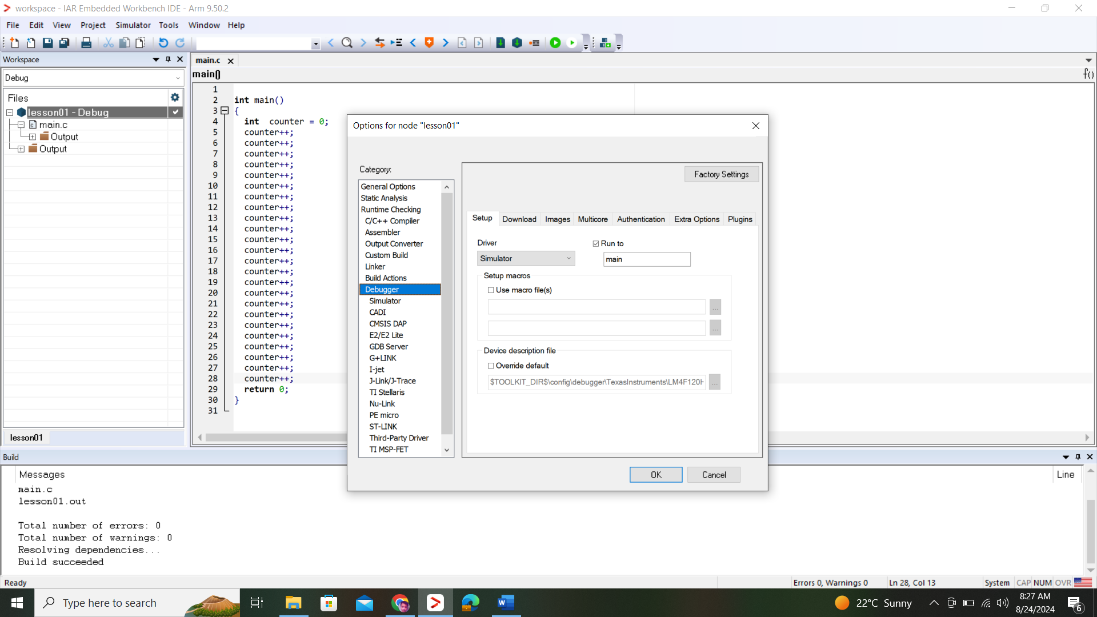

* To run debugger mode: crtl+d
* Open all the views in debugger mode
  + Disassembly
  + Memory
  + Register
  + Variable
* Since most of the arm instructutions are of 2 bytes of memory change memory view type to 2x

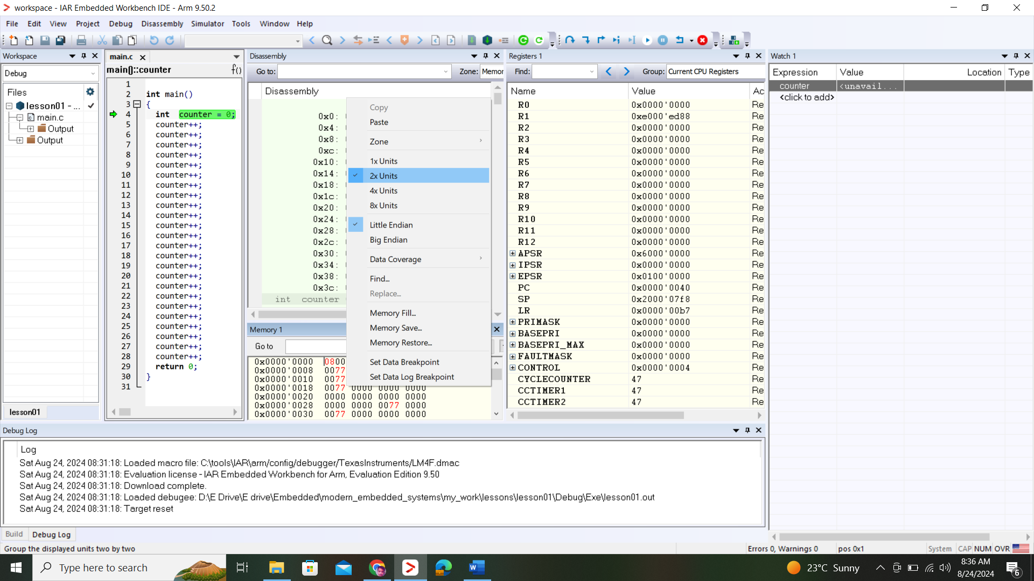

* You can see the same address in memory and disassembly window on memory address:

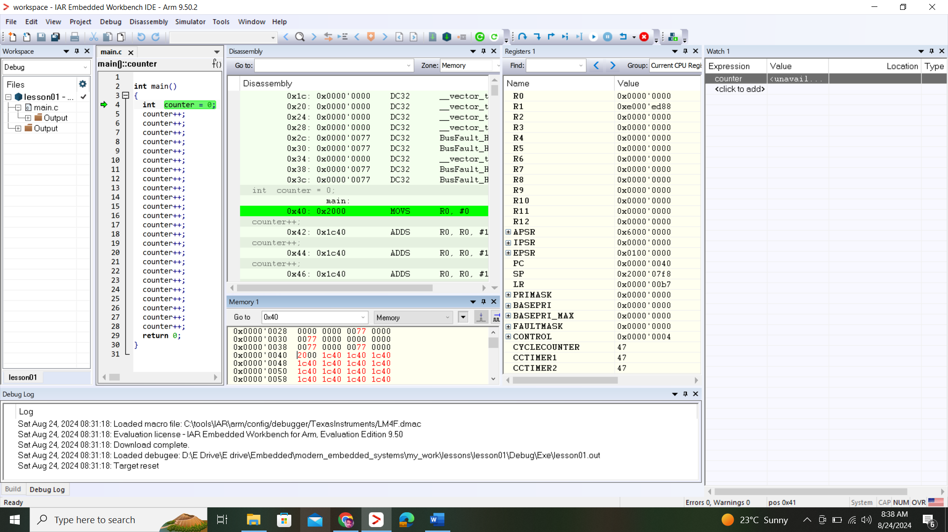

* ARM stores 16 registers, all these register can hold 32 bit numbers
* Machine instruction/opcode can manipulate the registers directly in one clockcycle
* The program runs sequenctially adding values to the counter until the 10 arrives, registers R0 showing value A
* Hex system uses nibble to represent number from 0-15
* Lets cheat and manually type a very very large number in watch window
* Type 0x7FFFFFFF and when you increment the counter the value in watch window of counter becomes -ve

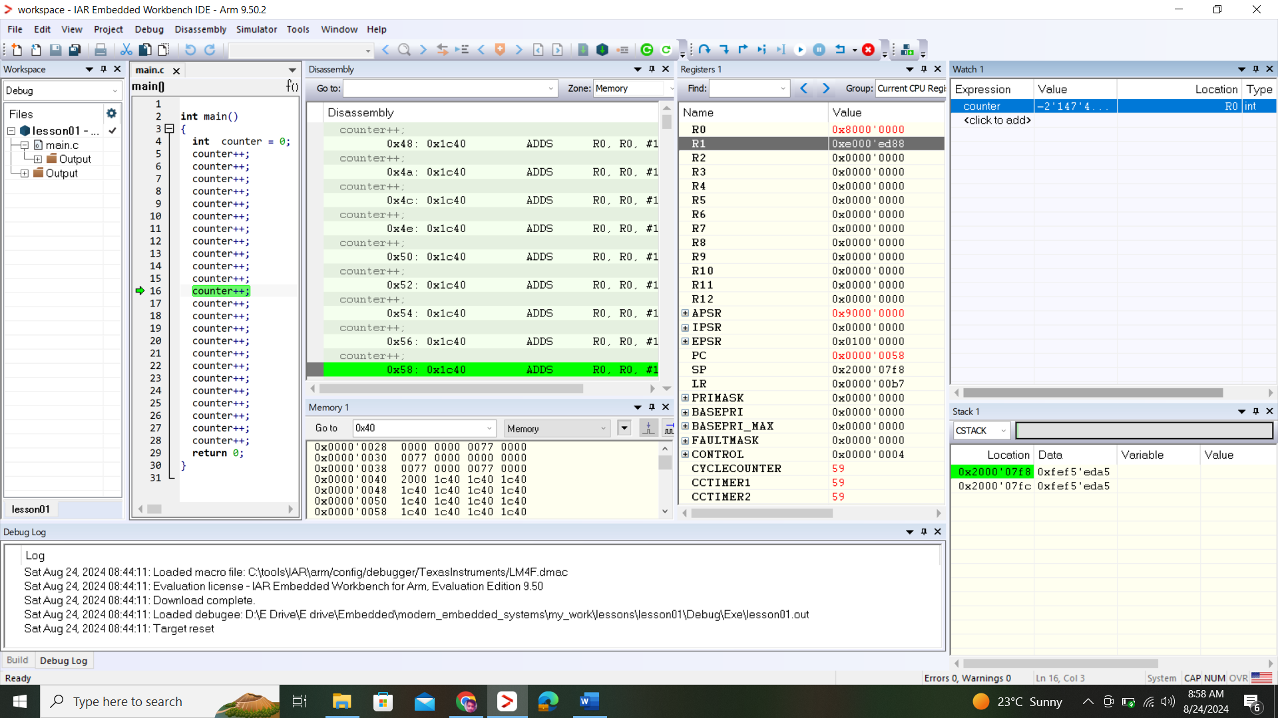

* This -ve number appears because computer uses 2’s complilment to do that, where MSB when turn to 8 highest -ve value appear and then when you increment it, the value becomes small in R0 Regsiter which means a register hold values from range: 0x00000000->0xFFFFFFFF

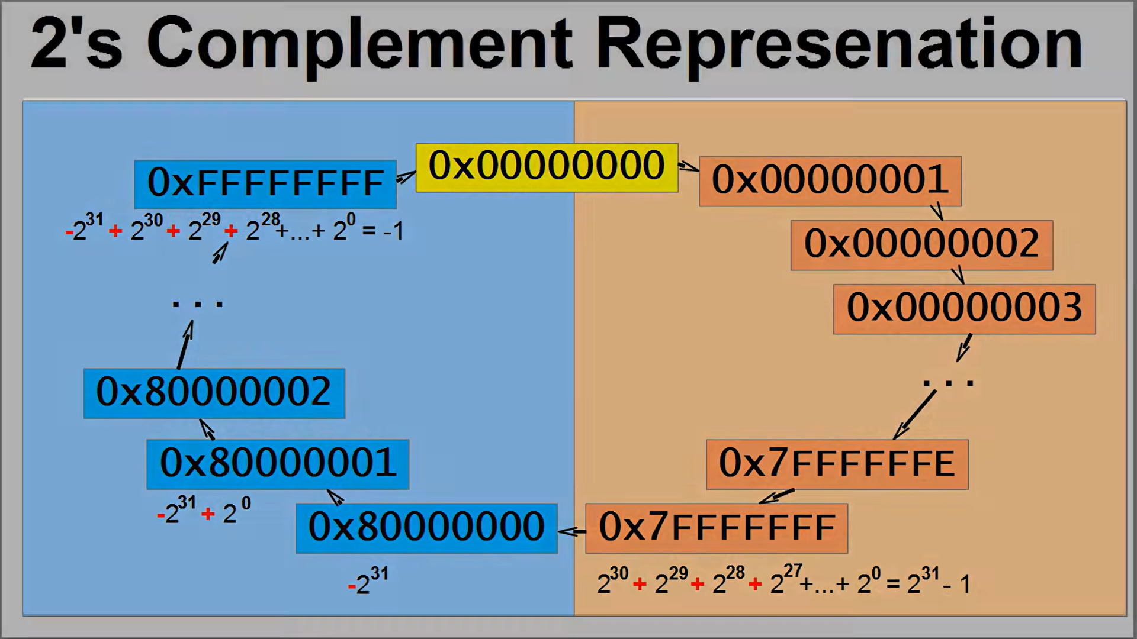

* To verify this, I enter -1 in watch window and check register 0 value, look what I got, an exact number that mentioned in the slide that also verifies the range

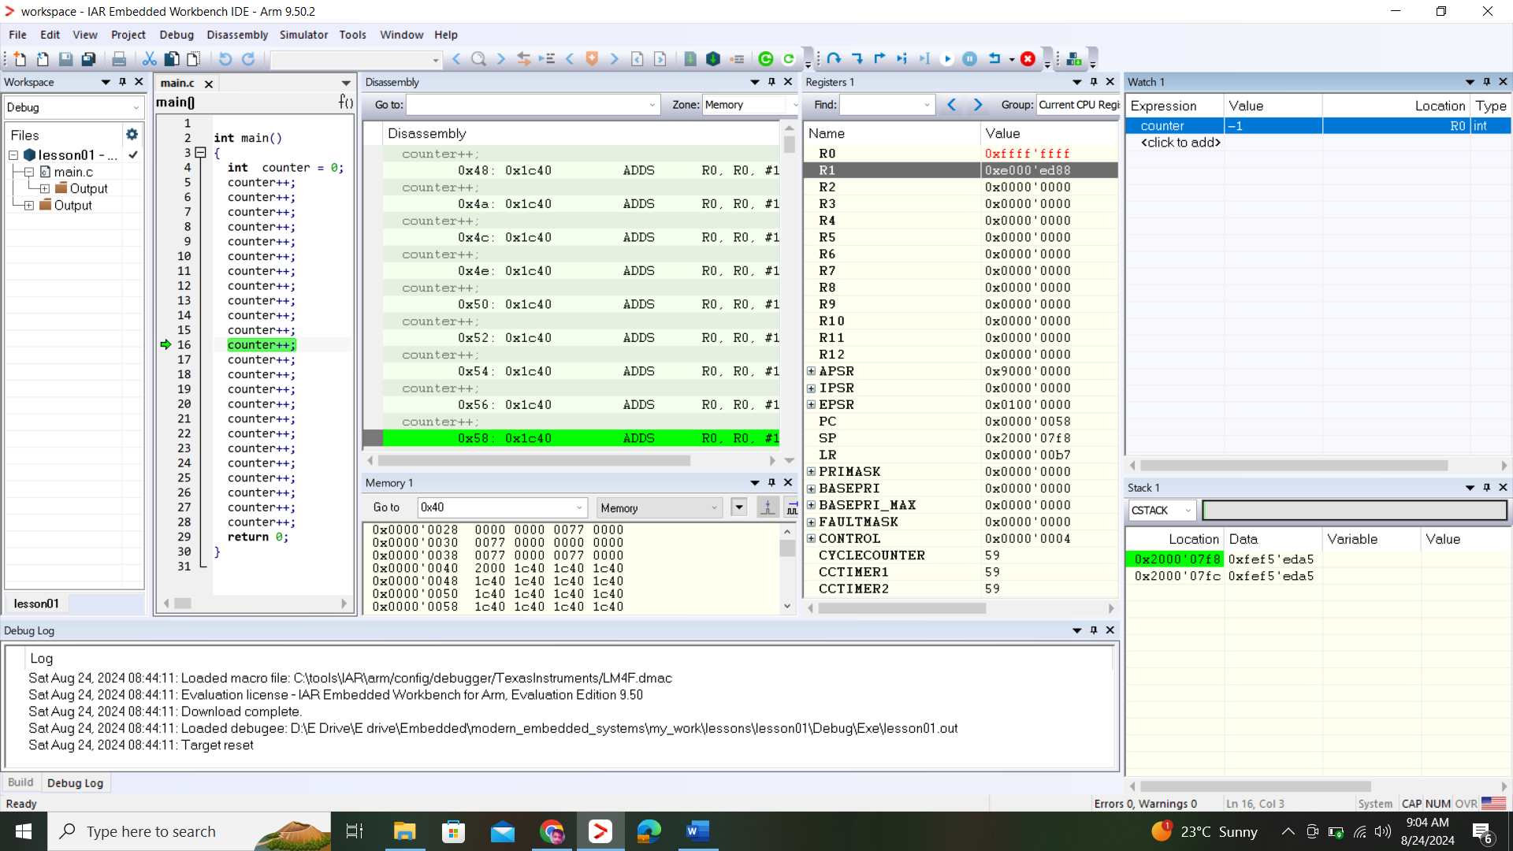

* **HOME WORK: do the Class work with unsigned int**
  + Step 01: change the type and enter the 0x7FFFFFFF into watch window
  + Step 02: step into and see the value

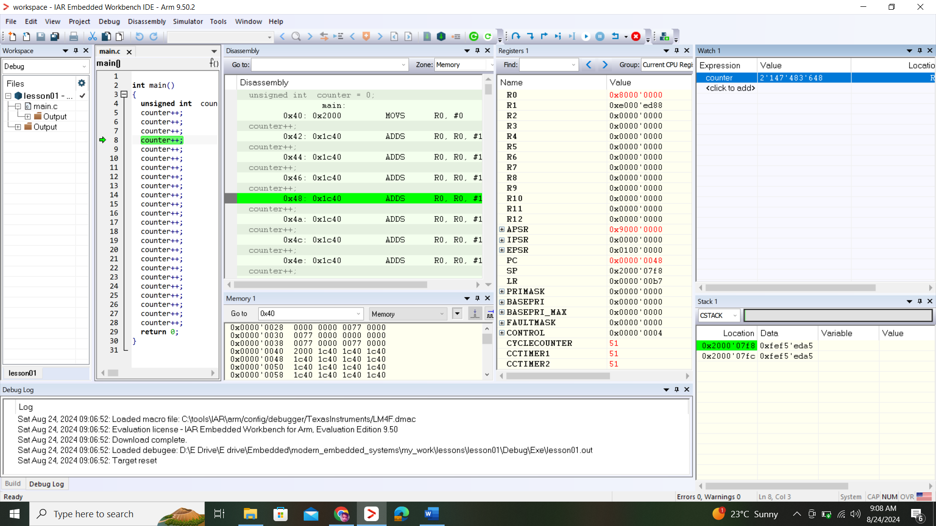

* + Step03: you can see that, when I increment it attain the same value just when I incremented signed int, but this time +ve
  + Step 04: That forced me to think that there must be some +ve range value is
  + Step 05: lets enter -1 and analyze

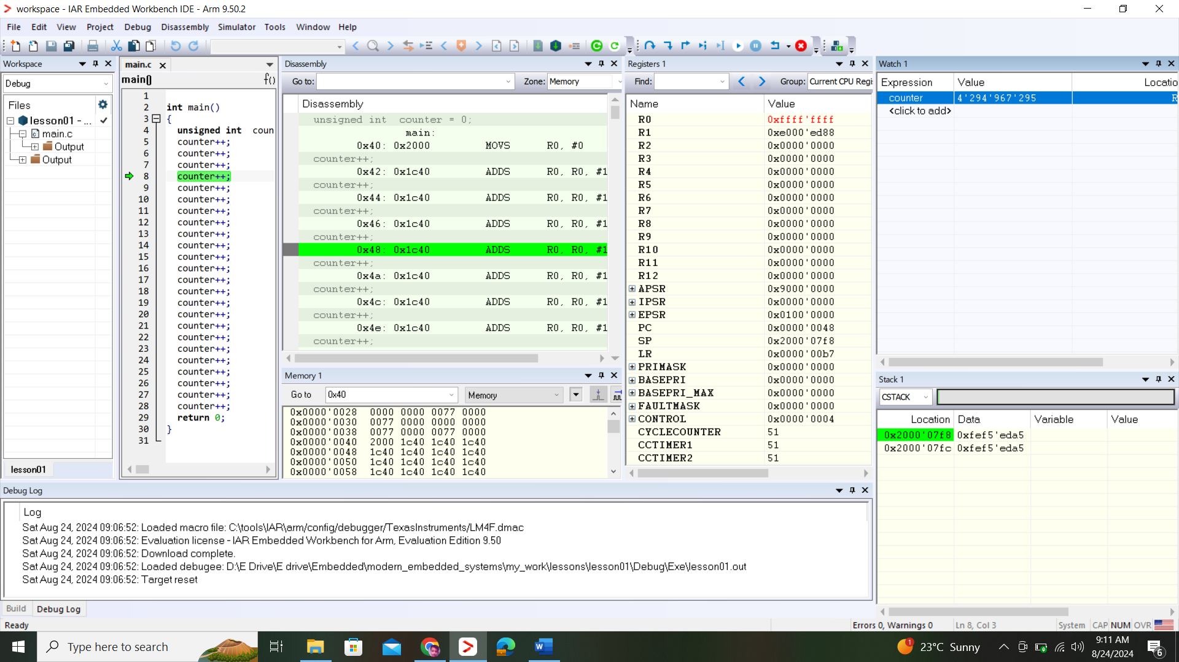

* + Step 06: you can see that the maximum +ve value it can attain is 4294967295 which is equivalent to 0xFFFFFFFF
* How to load the program into your board

**Lesson#02: How to change the flow of control through your code**

* Create a project
* Select a device LM4F120H5QR
* Compile a program fn+f7
* Now code is running sequentially now to break this sequential flow of execution
* Disassembly and Register view:
  + B.N instruction skips over some lines
  + CMP instruction compares R0 with the number that is mentioned at the condition of while loop, this instruction CMP performs subtraction(R0-21) thus it make APSR register’s N bit -ve
  + **BLT.N is a variant of BL instruction which is control flow instruction**
  + BLT.N instruction modifies the PC only when the N bit is set
  + BLT.N instruction controls the execution flow by redirecting to a memory location encoded by opcode
* How does the branch know where to jump?
* It encoded in the instruction of opcode which is 0xdbfc
* Lets open the datasheet of ARM architecture manual, and look at where all variants of T instructions are explained!
* 0Xdbfc:
  + d ~ means it use T1 variant among T
  + b ~ condition of instruction
  + fc ~ how much the pc should be change which is an offse
    - WHAT IS OFFSET?
    - A side quantity and which uses the 2’s complement
* Non-linear flow of control also impacts how fast the processor can execute the code.
  + There is loop over head, bec now you execute additional test and jumps just to handle the loop. But jumps add additional executing delays due to pipeline install
* What is pipeline?
  + All modern processors use instruction pipeline to increase the throughput. Where each instruction is split into multiple steps, like an assembly line which at one station performs 3 different operations e.g: fetch, decode, execute
  + All the instructions are ordered in number, when this ordering of instruction is disrupted by **Branch** instruction, the pipeline need to discard the instructions and jumps to new instruction and as we know the limited number if instruction can be loaded at 1 cycle that means, we create delays, that doesn’t we don’t use loops but be careful with that with time constraints codes.

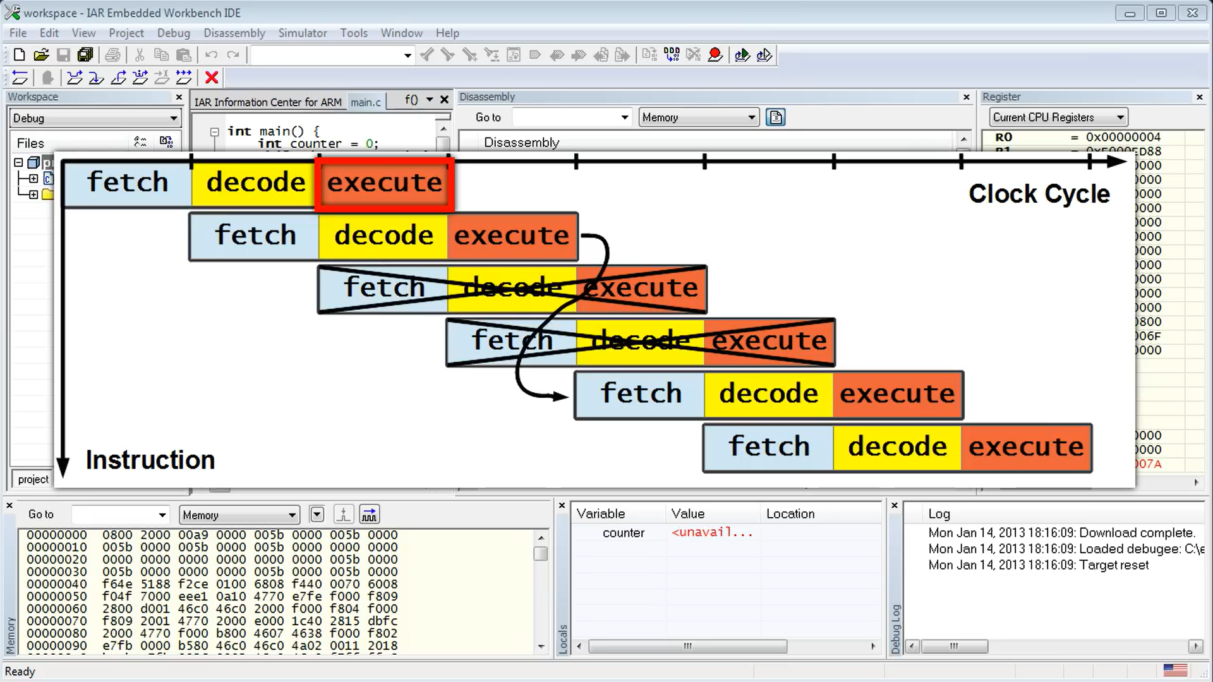

* + To increase the speed and reduce the delays increase the counter increment from +1 to +4
* The if statement:

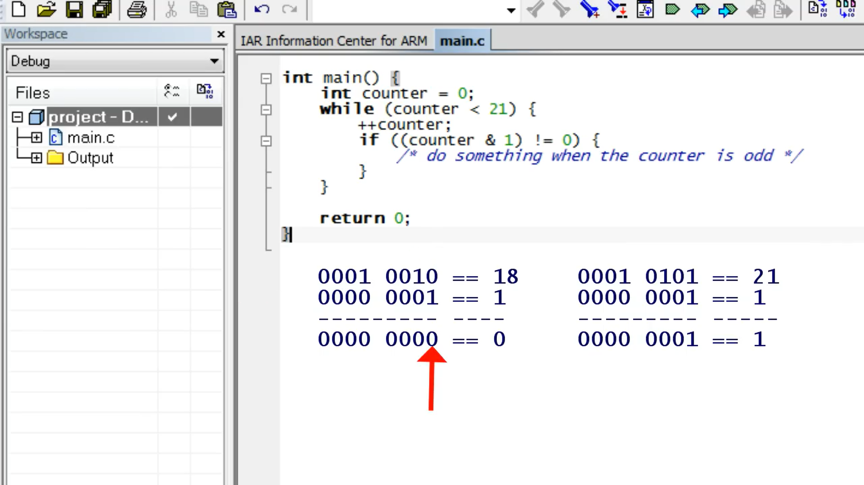

* & checks the comparison by comparing its LSB with the number, if they are equal then output would be 1 or True

**Lesson#03: Variables and Pointers**

* The global variables stored in RAM, thus it need to initialize when defined otherwise garbage value will be loaded
* The starting address of RAM is: 0x20000000

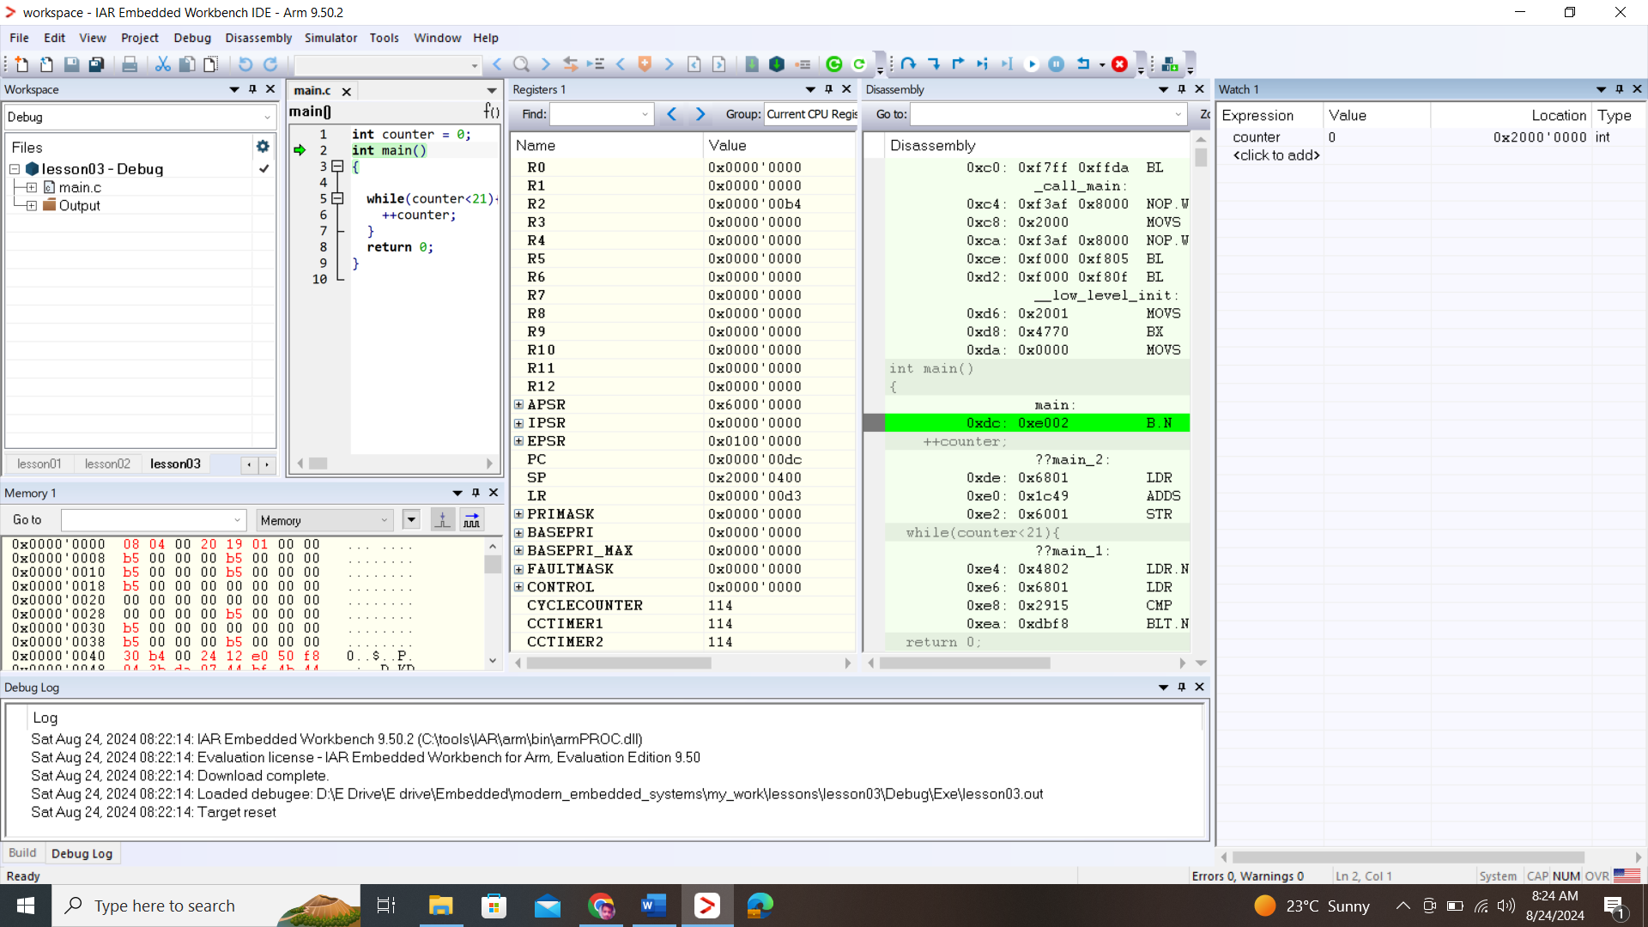

* Remain the code unchanged and analyze the machine instruction that is generated.
  + LDR.N: LDR instruction belongs to Memory access instruction here, here it loads something from main.0 to r0 register

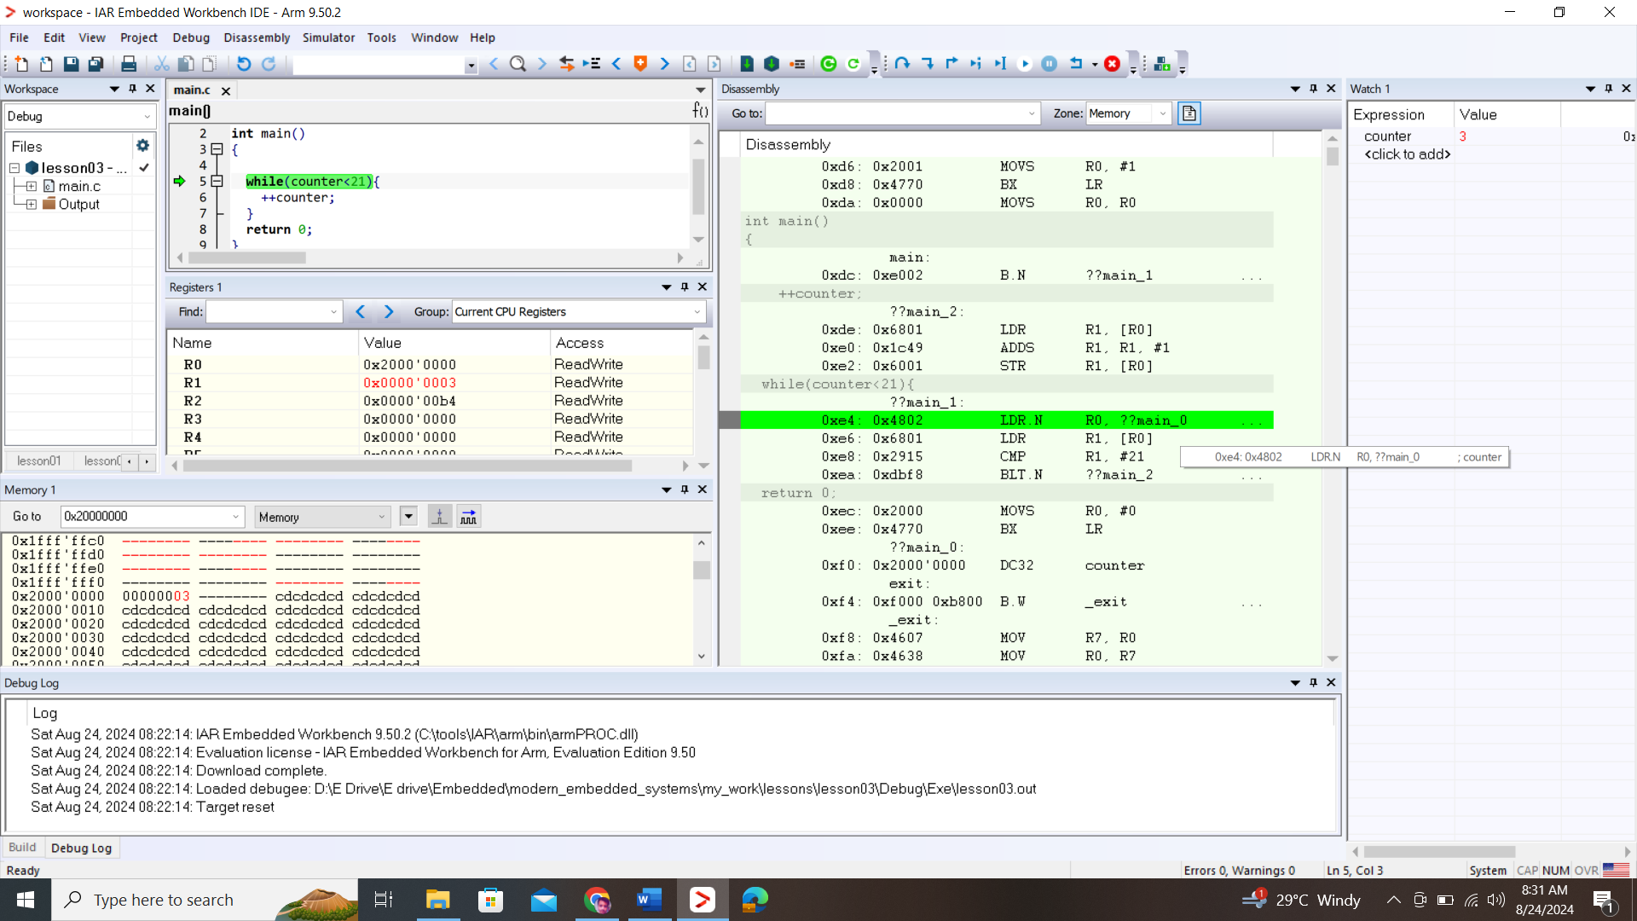

* + Next LDR instruction get the address from the address that LDR currently holds
  + **ADDS increment the counter variable**
  + **LDR** loads the address of counter variable to register
  + **STR** stores the value of a R0 Register to the memory pointed to by the R1 register
* **ARM** is an example of so called RISC (reduce instruction set architecture) where memory can be read by special load instructions (LDR), then all data manipulation happen in the registers, finally the modified register value can be stored back into the memory by the special store instruction
* The addresses in C level can be stored in the pointer variables.
* Using &variable can extract the address of a variable
* Using *pointer_variable, using * with a pointer variable means we are **dereferencing the pointer**, it means that the value stored in pointer variable (which is obviously the address), so that value is an address that is pointing to some value, **pointer_variable treats values as address**
* This simplifies the machine code
* Now move the new address into the pointer variable
* Enforce the type casting when (int *) when inserting new customize address into a pointer variable.
* Now poke into a random value into a pointer variable by dereferencing the pointer.
* The misaligned address accepted in memory view but it can be done in CORTEX M4 not in CORTEX M0

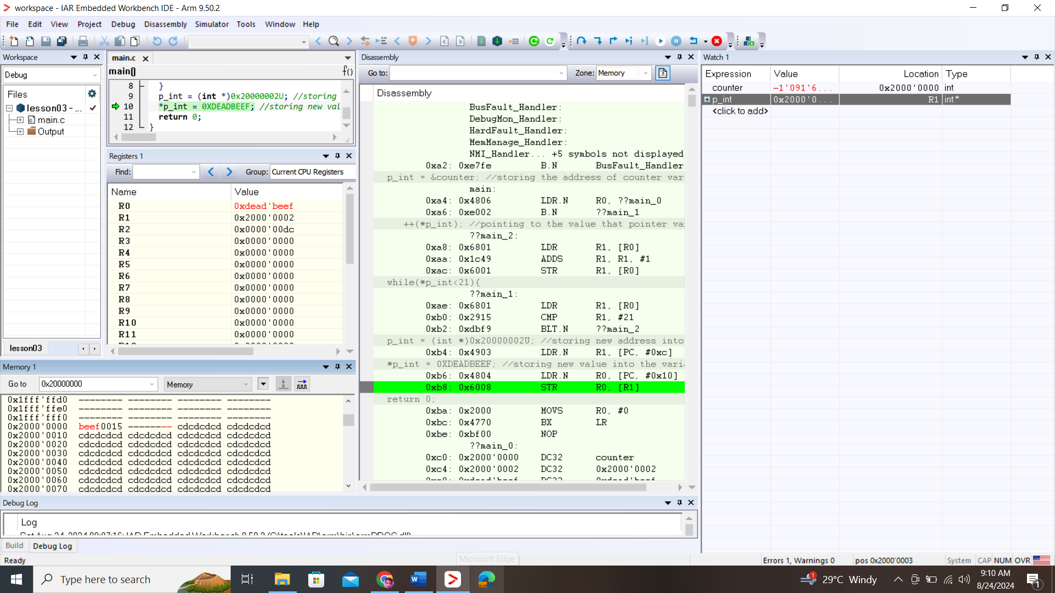

**Lesson#04: How to control the world outside?**

* Tiva C board datasheet:
  + User LED is connected to GPIO
  + LED GREEN, BLUE and RED are connected to pin PF1, PF2, and PF3 respectively

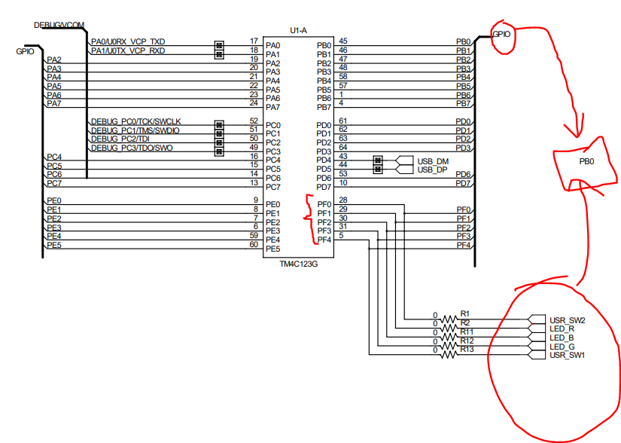

* The LED pins are connected to PORT F
* How to connect the device with the IAR !
  + Step01: 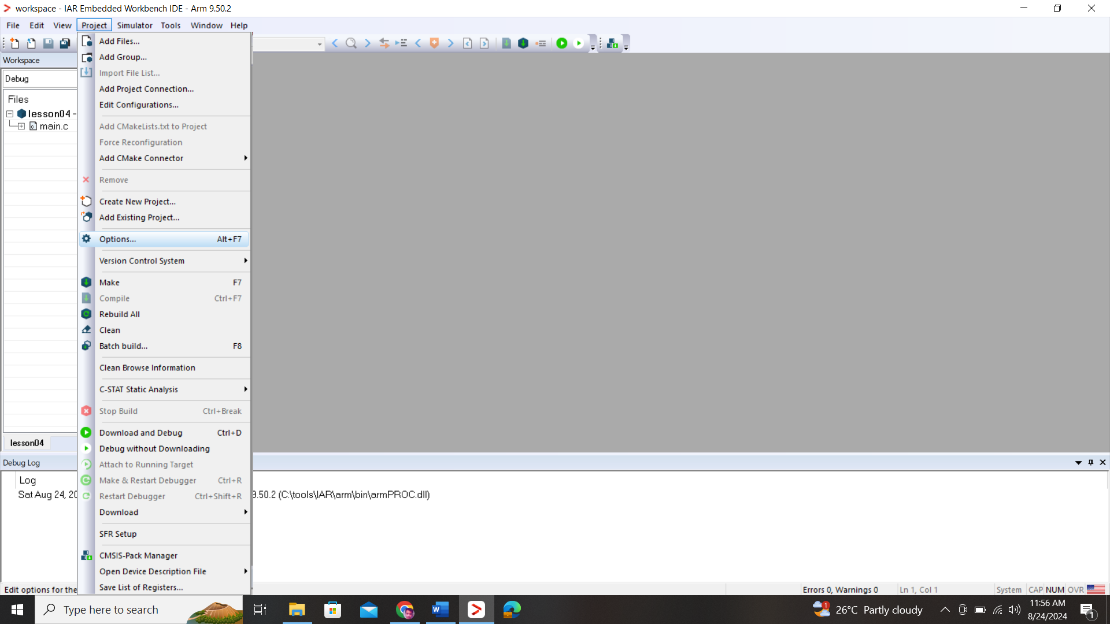
  + Step02: Change the driver of debugger from simulator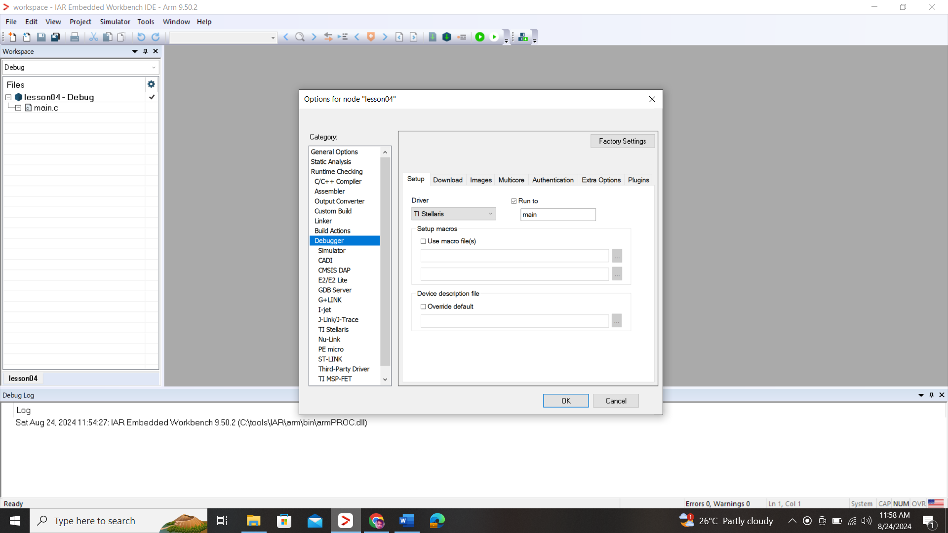
  + Step03: tick verify download and Use Flash loader(s) 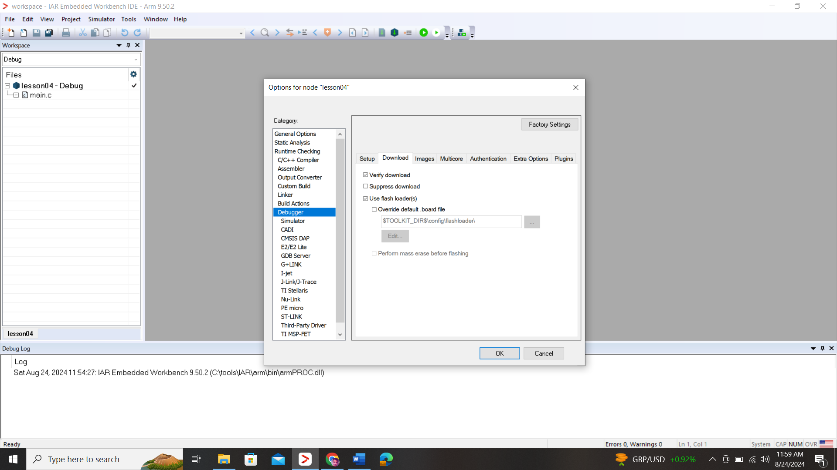
  + Steo04: Click on TI Stellaris and click on reset will do system reset, to always reset the board(NOT AVAILABLE IN CURRENT SOFTWARE)
  + Step05: To pulling in any previous main.c file rebuild the project
  + Step06: Select device which is LM4F120H5QR:
    - Click on project not main.c file
    - Project
    - Options
    - General
    - Target tab
    - Processor variant
    - Device-> select device
* The addresses starting from 0 mapped to flash memory and where your compiled code remain safe. 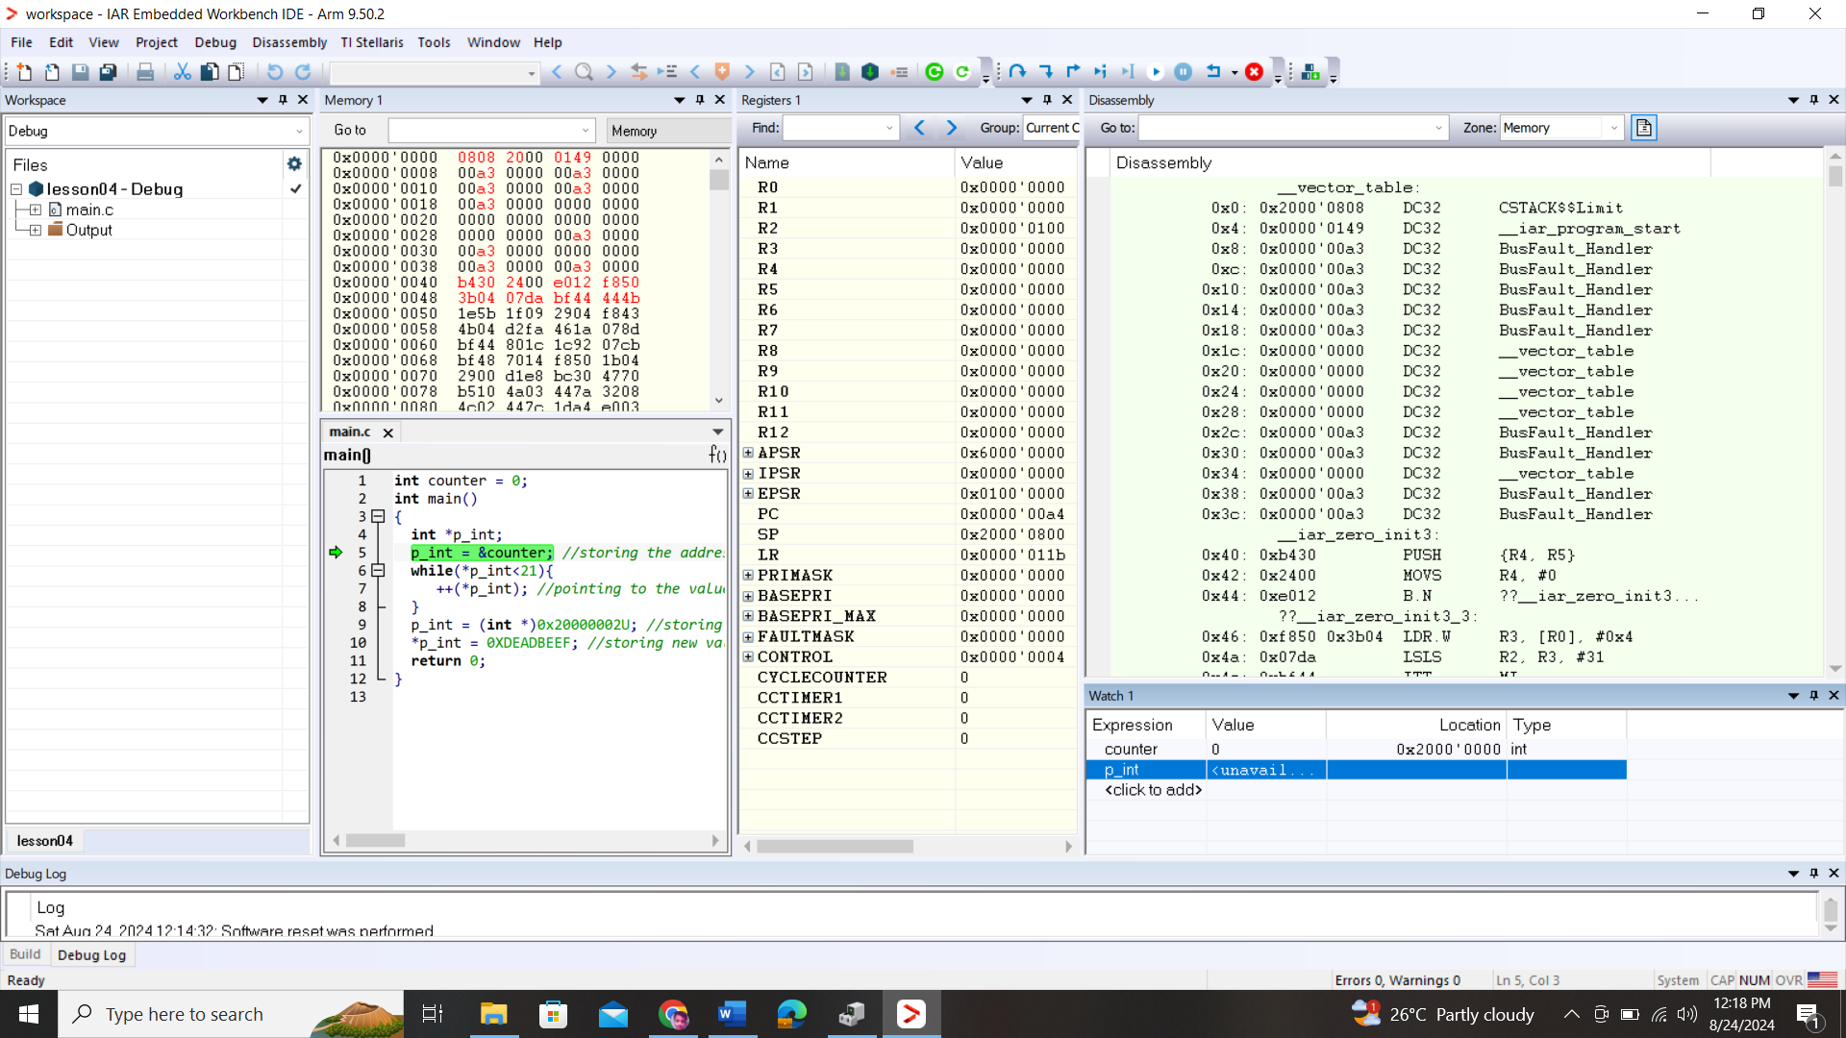
* You also know that addresses start from 0x20000000 are mapped to RAM but the address above that in memory view can be seen ----- indicating that they are unused.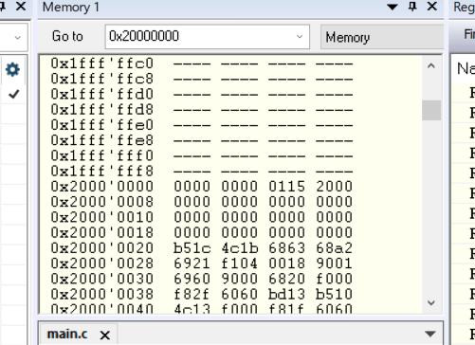
* The same ---- appear after 0x20008000 indicating that the range of addressing for RAM in TIVA C board is from 0x20000000->0x20008000.
* The range of RAM makes up to 32Kb of RAM
* In the same way to find your interested memory maps or island you need to refer to that specific datasheet **TM4C123GH6PM**
* To understand the memory map you need to search in your respective device “memory map” and see all the ranges assign to GPIOS RAM and so on
* I found the table of memory map at page#92
* You will recognize in the table about the GPIO ports and RAM and Flash ranges
* We are looking for GPIO ports.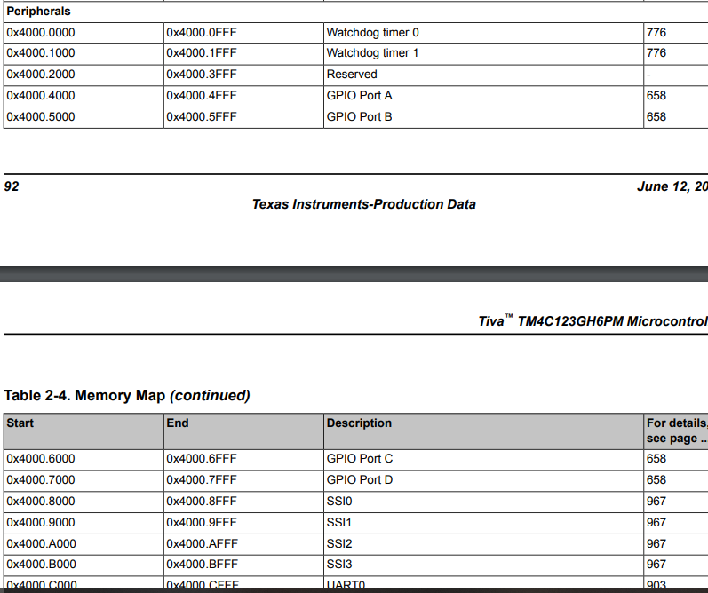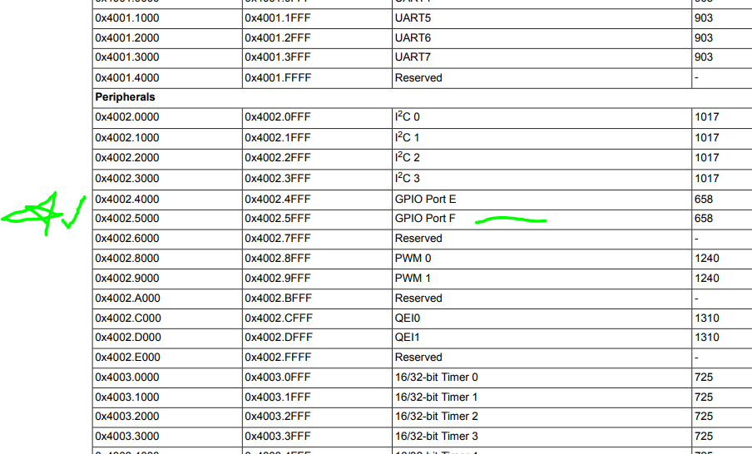
* Copy the starting address of **0x4002.5000 of portF** and take it to the debugger and paste into memory view, we noticed that are empty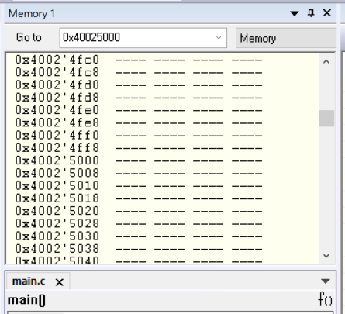
* The typical reason is that the hardware block is switched off by default to save power
* The technique of blocking the clock signal to certain part of chips is called **clock gating** which is a very common practice in modern mcirocontrollers.
* In order to discover GPIOF block ON you need to go through the datasheet again
* Since the problem is regarding with clock gating search “clock gating” then when you found a page search for gpio and we found at page#340 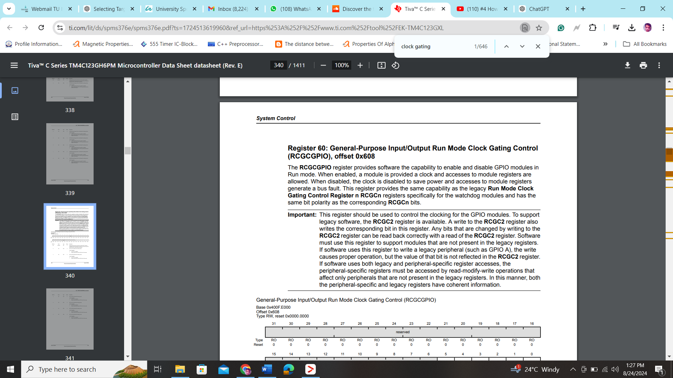
* Now we look under register description and try to understand
* Register name: Register 60: General-Purpose Input/Output Run Mode Clock Gating Control (RCGCGPIO), offset 0x608
* Each register’s mode can be set :Read Only, WO: Write Only, R/W: Read and Write
* RCGCGPIO is a 32-bit wide register where it has 32 bits, among them R0-R5 controls its mode
* For us the most important bit is **R5 or bit 5 which is a GPIO Port F Run Mode Clock Gating Control** and it says that:
  + Value Description
    - 0 GPIO Port F is disabled.
    - 1 Enable and provide a clock to GPIO Port F in Run mode.
* Which means we gotta disable the pin but how?
  + Copy the base address 0x400F.E000
  + Notice the offset 0x608 needs to added to the base to get the complete address of the register
  + **Which makes the complete address : 0x400F.E608**
  + If the register address is  **0x400F.E608** and its bit 5 needs to be set, which means that from LSB, stop at **R5th register or 6th bit** and turn it into 1, this binary representation looks like this 0b00000000000000000000000000100000
  + It hexadecimal is **0x00000020**
  + **Finally we set the register 0x4000E608=0x00000020**
  + This can be done in code or in symbolic memory view.
* Since we are looking to turn up the GPIOF port whose address **0x4002.5000:**
  + In symbolic memory view **0x4000E608=0x00000000 due to that 0x4002.5000= -----------** 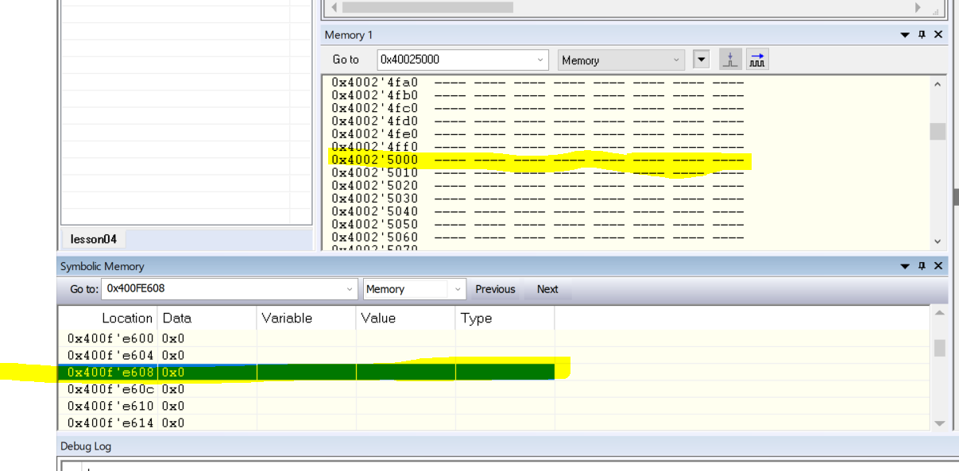
  + **After setting up** view **0x4000E608=0x00000020 due to that 0x4002.5000= 0000 0000 0000 0000 means that GPIOF turns up**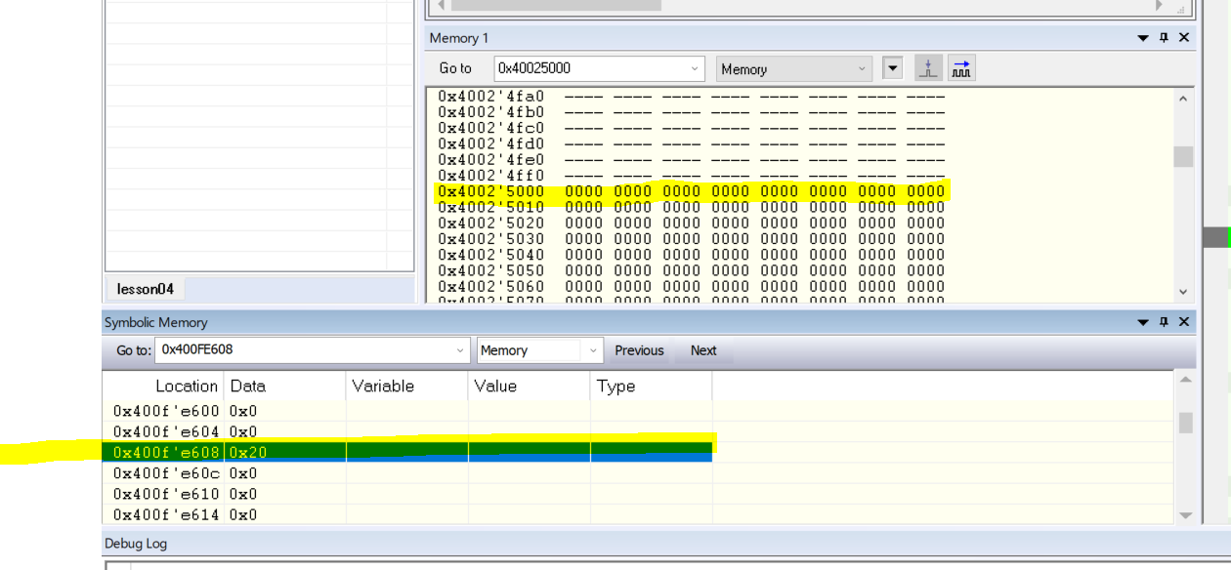
* Your work isn’t finish up of blinking and LED as you can read in datasheet that to turn on the led you need to configure the **GPIOF’s bits which are 1,2,3** which drives the RGB as digital output which is GPIO Direction (GPIODIR), offset 0x400 at page #663, Look at GPIO Port F= 0x40025000 with offset it becomes **0x40025400**

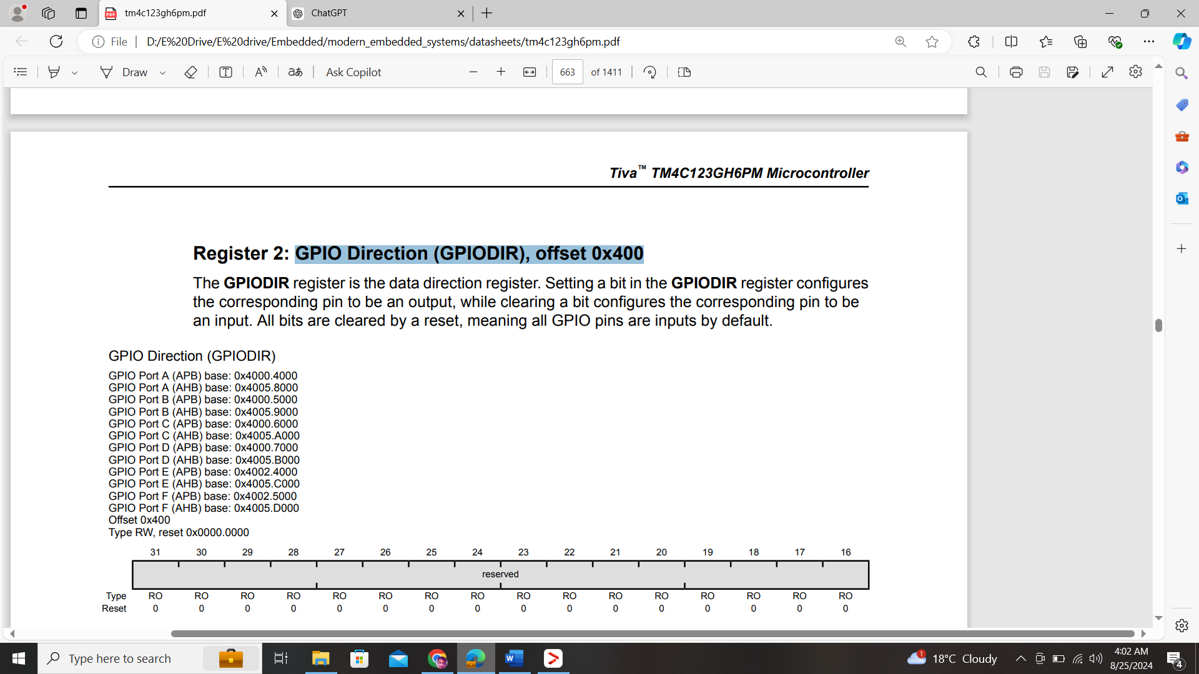

* Use this register **0x40025400** to set pin 1,2,3 high which means that we need to update its value which corresponds to 1110 in binary and **e** in HEX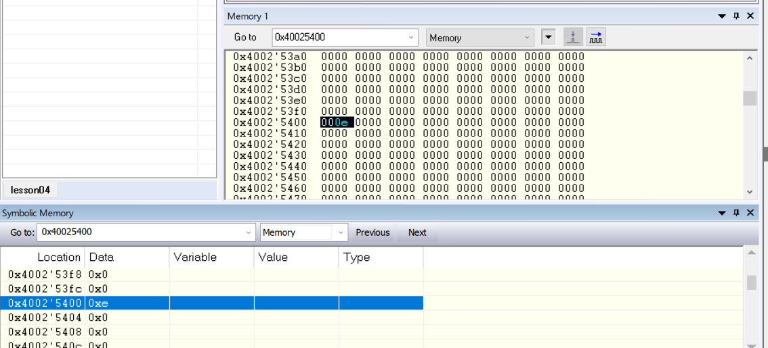
* Now additionally we have to **set the function of the pins as digital output** scroll further down and find **0x4002551C** and set 1,2,3 high which is equivalent to putting value **e IN LOWEST NIBBLE** in HEX which makes **0x40025510** 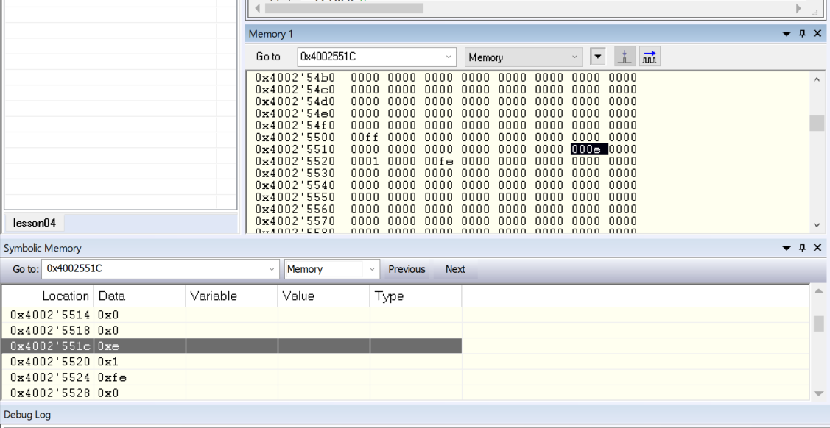
* Now finally you can try to control the LED by manipulating GPIOF **Data register** which is located at **0x400253FC,** scroll to this register and set its 2nd bit as 1 which is equivalent to 2 HEX in lowest nibble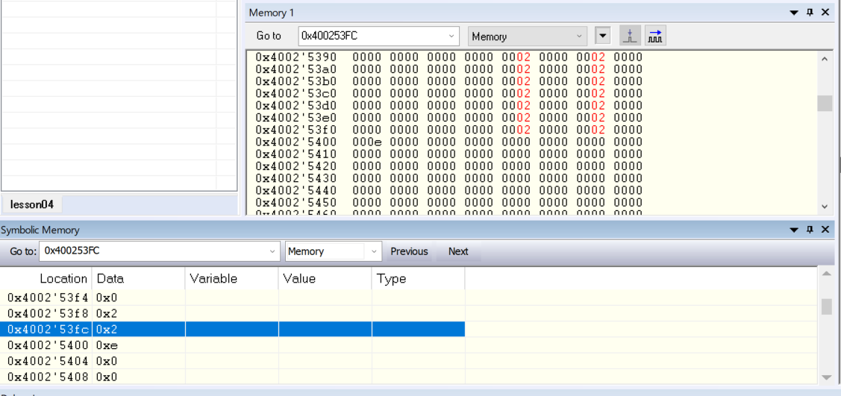

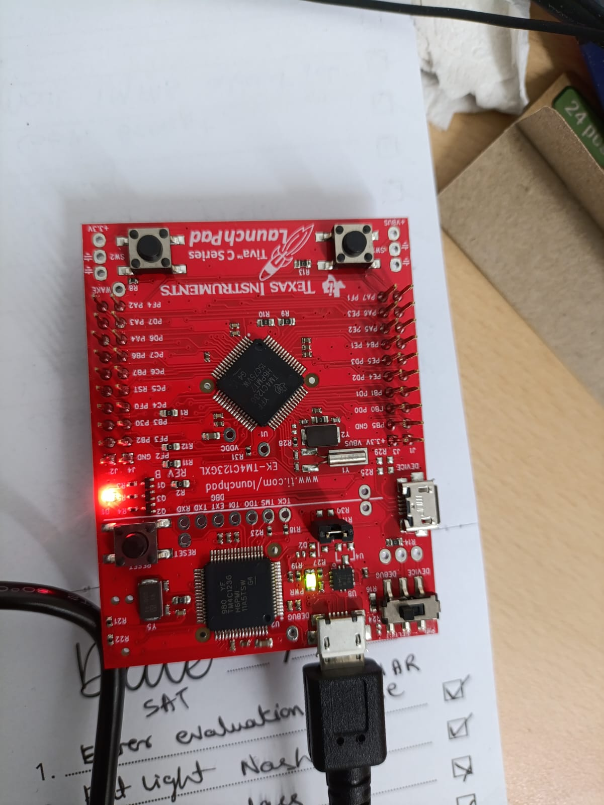

* Now code this into C using pointers
* Don’t create a separate pointer variable, instead do de-reference the pointer cast
* Algorithm from above to work:
  + Turn on GPIOF Register by setting up **0x4000E608=0x00000020**
  + Configure LED pin direction register **0x40025400=0x0000000E**
  + To set the pins as digital output set register **0x4002551C=0x0000000E**
  + Setting led turn on or off LED Data Register **0x400253FC:**
    - **0x400253FC = 0x00000000 -> no color**
    - **0x400253FC = 0x00000002 -> RED**
    - **0x400253FC = 0x00000004 -> Blue**
    - **0x400253FC = 0x00000008 -> Green**
    - **0x400253FC = 0x0000000A -> Blue and Red ==Yellow**
    - **0x400253FC = 0x0000000C -> Blue and Green == Sky Blue**
    - **0x400253FC = 0x0000000E -> All colors on == White**
* **Employ the algorithm using de-referencing technique**
* When I coded and run step into the code works fine but when I run the code the led did not blink and remain on why??
* Because we cannot percept the blinking of led thus we need to slow the program
* So we have create a delays using extra loops